SpeedSwivel FDC Adapter: Training Guide Nov. 2023
Red Head Brass

SUBJECT: The SpeedSwivel FDC adapter
A Speed Swivel provides firefighters a tool and a solution for connecting fire hose to a fire department connection (FDC) when the brass swivels are missing or have been stolen.

- SPEEDSWIVEL TRAINING HANDOUT
A. Defines the Speed Swivel.
- Establishes the issuance of the Speed Swivel.

- Establishes guidelines for appropriate use, care, and storage of the Speed Swivel.

- Effective Date _____/______/_____.

11. POLICY
It is the policy of the ________ Fire Department to provide the necessary tools to assist when operating safely at the scene of an incident. The Speed Swivel provides firefighters a solution for connecting fire hose to a fire department connection (FDC) when the brass swivels are missing or stolen. Fire fighters shall be responsible for the proper care and use of this hose adapter.

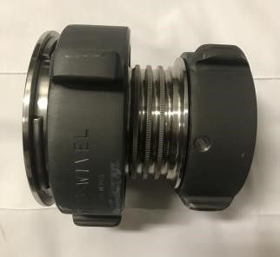
111. DEFINITIONS

Speed Swivel: A fitting that replaces a missing FDC female swivel by fitting over and tightening onto the ball bearing raceway.

Locking Collar
2 ½” female swivel connection

Page 1 of 5
IV. OPERATIONAL USE OF THE SPEED SWIVEL

The Speed Swivel shall be used when the 2 ½” female swivel of an FDC has been stolen or is missing. When connecting to a vandalized FDC that is missing the female threaded swivel, the member shall:

      - Ensure the barrel of the FDC is clear of debris and that there is no damage to the ball bearing raceway of the missing swivel.

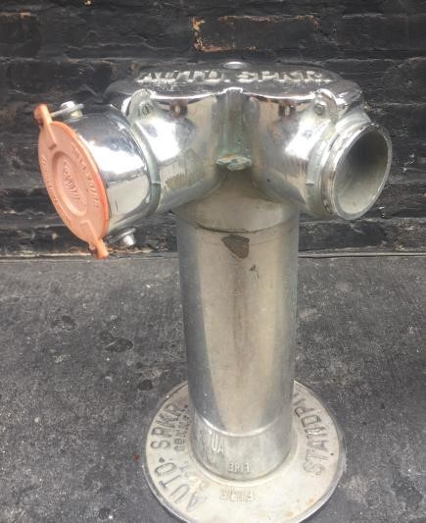

Female Swivel Bearing Raceway

      - Confirm the Speed Swivel is in the open position by turning the Locking Collar counter-clockwise until the four locking mechanisms have retracted back into the housing.
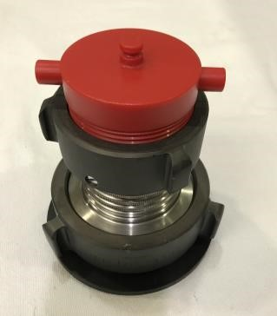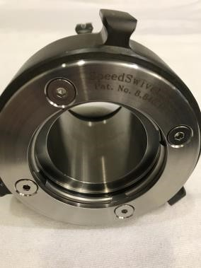

Locking
Collar

Locking
mechanisms

Page 2 of 5
      - Place the Speed Swivel onto the intake port of the FDC with the 2 ½” female swivel connection of the Speed Swivel facing out.

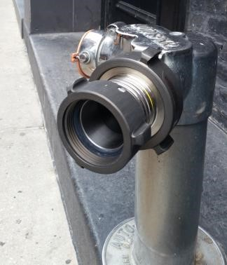

2
½” female swivel
connection

      - Turn the Locking Collar clockwise (or to the right) until it is hand tight.

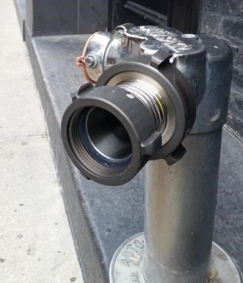Locking Collar

      - Attach the 2 ½” fire hose to the 2 ½” female coupling provided on the SpeedSwivel.
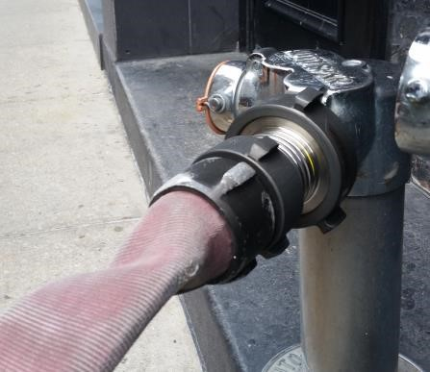NOTE: Depending on the age and condition of the FDC, some leaking around the fitting is normal.

2
½” hose

2
½” female swivel
connection

Page 3 of 5
The Protective Black Anodized Dust Cover:

The Black “Protective Cover” has a ball-race that duplicates/simulates the attachment of a SpeedSwivel to a vandalized FDC. This “Protective cover” is also a useful training prop. The knowledge needed by a firefighter to remove & attach this dust-cover will reinforce the knowledge needed to attach the SpeedSwivel to a “Vandalized FDC” in an emergency.
The ball-race design duplicates the size-shape of the ball-race found on a vandalized FDC.
To remove the dust-cover, spin the large Locking Collar/Coupling (three-five spins).
Pulling and/or spinning the black cover will not allow the removal of the “black” cover!

With one hand, Grasp the SpeedSwivel firmly in the middle (barrel) section. Make sure the largest end is facing up and the smaller 2.5 female coupling is facing toward the floor. Do not spin or tug at the top cover plate until you release it by spinning the large Rocker Lug coupling 3-5 spins. Avoid dropping the collar completely off the threaded body (to many spins) unless you wish to brush or clean the threads on the main body or the couplings.

The “Black” protective-dust-cover is provided with every SpeedSwivel sold and should remain attached when device is stored in a truck compartment and not in use.

RESPONSIBILITES of customer/user: Per NFPA 1962

- Fire fighters shall be responsible for the proper care and use of this hose adapter.
- Upon receipt, the Speed Swivel shall be added to all appropriate truck inventories.
- Any damage and/or signs of wear to the Speed Swivel shall be reported.
- Check female threads for compatibility with your departments 2-1/2 inch male hose.
- Refer to NFPA 1962 for care and maintenance of fire hose, nozzles, and adapters.
- USA made, meets all NFPA requirements.
- Visit SpeedSwivel.com for information on use and purpose for this portable tool.

Page 4 of 5

YOUR DEPARTMENT NAME HERE:

_______________________________________________________
Visit us: www.redheadbrass.com

Contact:

Office:

E-mail:

U.S. Patent No. 8,840,149

Download this information from www.redheadbrass.com

Revised Nov. 1, 2023

Page 5 of 5

